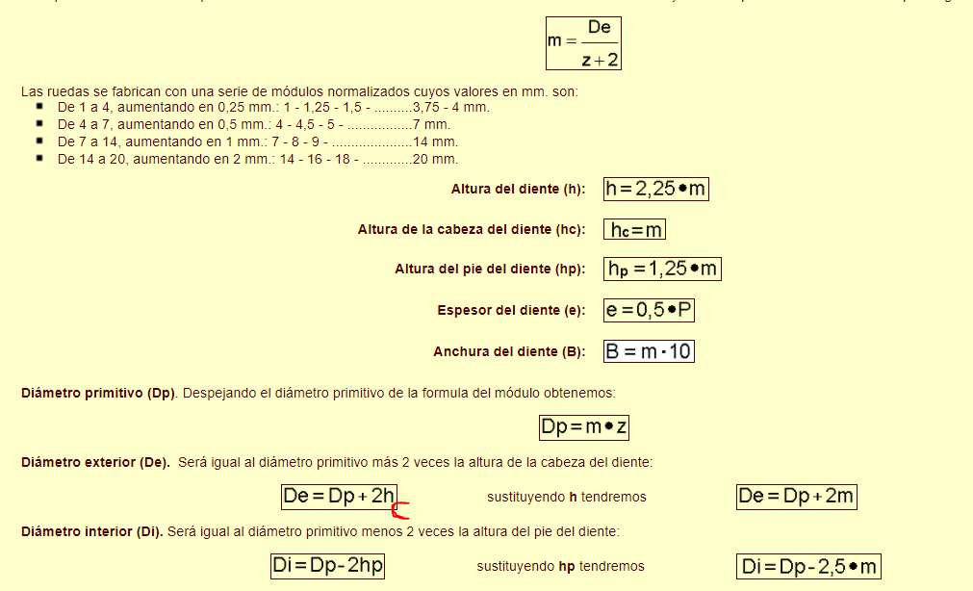

Eje 1

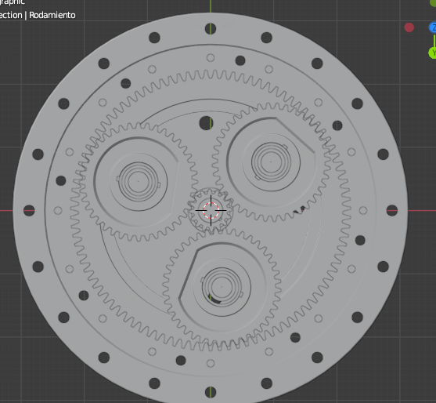

Piñón 1=16 DP=48 M=3 DE=54 DI=40.5 h=6.75 engranaje recto

Piñón 2=40 DP=120 M=3 DE=126 DI=112.5 h=6.75 engranaje recto

Piñón 3=95 DP=285 M=3 DE=291 DI=277.5 h=6.75 engranaje recto

1rpm

95\*1/40=2.375

40\*2.375/16=5.9375

Eje 2

Piñon 1=35 DP=61.25 M=1.75 DE=64.75 DI=56.875 h=3.9375 engranaje recto

{Piñon 2=21 DP=36.75 M=1.75 DE=40.25 DI=32.375 h=3.9375 engranaje recto

Piñon 3=20} DP=40 M=2 DE=42.52 DI=24.54 h=9 engranaje cónico helicoidal - KHK MMSA2-20R

{Piñon 4=20 DP=40 M=2 DE=42.52 DI=24.54 h=9 engranaje cónico helicoidal - KHK MMSA2-20L

Piñon 5=1} DP=31 M=2 DE=35 DI=25 h=5 Tornillo sin fin - KHK KWGDL2-R1

{Piñon 6=52 DP=104 M=2 DE=106 DI=102 h=5 corona

Piñon 7=30} DP=75 M=2.5 DE=80 DI=68.75 h=5.625

Piñon 8=90 DP=225 M=2.5 DE=230 DI=218.75 h=5.625

90\*1/30=3

52\*3/1=156

21\*156/35=93.6

Eje 3

Piñon 1=18 DP=27 M=1.5 DE=30 DI=23 h=3.5 engranaje recto - KHK MSGA1.5-18

{Piñon 2=32 DP=48 M=1.5 DE=51 DI=44 h=3.5 engranaje recto - KHK SSA1.5-32

Piñon 3=20} DP=40 M=2 DE=42.52 DI=24.54 h=9 engranaje cónico helicoidal - KHK MMSA2-20R

{Piñon 4=20 DP=40 M=2 DE=42.52 DI=24.54 h=9 engranaje cónico helicoidal - KHK MMSA2-20L

Piñon 5=1} DP=31 M=2 DE=35 DI=25 h=5 Tornillo sin fin - KHK KWGDL2-R1

{Piñon 6=42 DP=84 M=2 DE=88 DI=78 h=5 corona

Piñon 7=42} DP=105 M=2.5 DE=110 DI=98.75 h=5.625

Piñon 8=58 DP=145 M=2.5 DE=150 DI=138.75 h=5.625

Piñon 9=120 DP=300 M=2.5 DE=305 DI=293.75 h=5.625

120\*1/58= 2,06896551724

58\* 2,06896551724/42= 2,85714285714

42\* 2,85714285714/1=120

120\*32/18=213.33333333

Eje4

Piñon 1=18 DP=18 M=1 DE=20 DI=15.5 h=2.25 engranaje recto - KHK SUS1-18

[Piñon 2=80 DP=80 M=1 DE=82 DI=77.5 h=2.25 engranaje recto - KHK SSAY1-80

Piñon 2=14] DP=21 M=1.5 DE=24 DI=17.25 h=3.375 engranaje recto

Piñon 3=80 DP=120 M=1.5 DE=123 DI=116.25 h=3.375 engranaje recto

80\*1/14=5.71428571429

80\*5.71428571429/18=25.3968253968

Eje 5

Piñon 1=25 DP=62.5 M=2.5 DE=67.5 DI=56.25 h=5.625

[Piñon 2=42 DP=105 M=2.5 DE=110 DI=98.75 h=5.625

Polea 1=\*\* D=108

Polea 2=\*\*] D=108

42\*1/25=1.68

Eje 6

Piñon 1=25 DP=62.5 M=2.5 DE=67.5 DI=56.25 h=5.625

[Piñon 2=42 DP=105 M=2.5 DE=110 DI=98.75 h=5.625

Polea 1=\*\* D=108

Polea 2=\*\* D=108

Piñon 3=25 DP=62.5 M=2.5 DE=65.54 DI=37.4 h=5.625 engranaje cónico helicoidal - KHK MMSA2.5-25L

Piñon 4=25 DP=62.5 M=2.5 DE=65.54 DI=37.4 h=5.625 engranaje cónico helicoidal - KHK MMSA2.5-25R

Piñon 5=12] DP=18 M=1.5 DE=21 DI=14.25 h=3.375 engranaje recto

Piñon 6=40 DP=60 M=1.5 DE=63 DI=56.25 h=3.375 engranaje recto

Piñon 7=92 DP=138 M=1.5 DE=141 DI=134.25 h=3.375 engranaje recto

92\*1/40=2.3

40\*2.3/12=7.66666666667

42\*7.66666666667/25=12.88